#### UNIVERSITY OF BUEA

**\*\*\*\*\*\*\*\*\*\*\*\*\*\***

#### FACULTY OF ENGINEERING AND TECHNOLOGY

**\*\*\*\*\*\*\*\*\***

#### DEPARTMENT OF COMPUTER ENGINEERING

**\*\*\*\*\*\***

#### 2022/2023 ACADEMIC YEAR

PROJECT REPORT TITTLED;



Mobile Application Development

Hybrid, Native, and Web Application development

**GROUP MEMBERS SUPERVISOR;**

**Dr. Valery Nkemini**

|  |  |
| --- | --- |
| **NAMES** | **MATRICULES** |
| **ENEMBE VERINE** | **FE20A033** |
| **AYAMBA OJONG NKONGHO** | **FE20A019** |
| **TONY KENYUI NANGAH** | **FE20A120** |
| **NKONGHO AYUK SHARIMA** | **FE20A090** |
| **GABILA YASMIN NAHKUNA** | **FE20A043** |

#### FRIDAY, MARCH 31st 2023

1. Different mobile apps and their differences.

The different types of mobile Apps include;

**\* Native apps** are created for one specific platform or operating system.

* **Web apps** are responsive versions of websites that can work on any mobile device or OS because they’re delivered using a mobile browser.

**\* Hybrid apps** are combinations of both native and web apps, but wrapped within a native app, giving it the ability to have its own icon or be downloaded from an App Store

1**. Native Apps**

Native apps are built for a dedicated operating system on a device. For example Android apps and iOS apps. You can’t mismatch them. That is use an iOS dedicated app on an Android OS. Can be coded using simple programming languages like C/C++ Python Java Objective C

For Android OS, this android coding language is Java,

**Advantages**

* Faster and reliable performance.
* Native apps connect with the device hardware hence offer capabilities like Bluetooth, Camera Roll Contacts. Etc

**Disadvantages**

* Costly as in a code created for one platform can not be reused in another platform. Duplicate effort for each platform.
* Whenever there’s a new version, the user has to update and install it his device. Meaning native apps take a good amount of device storage.

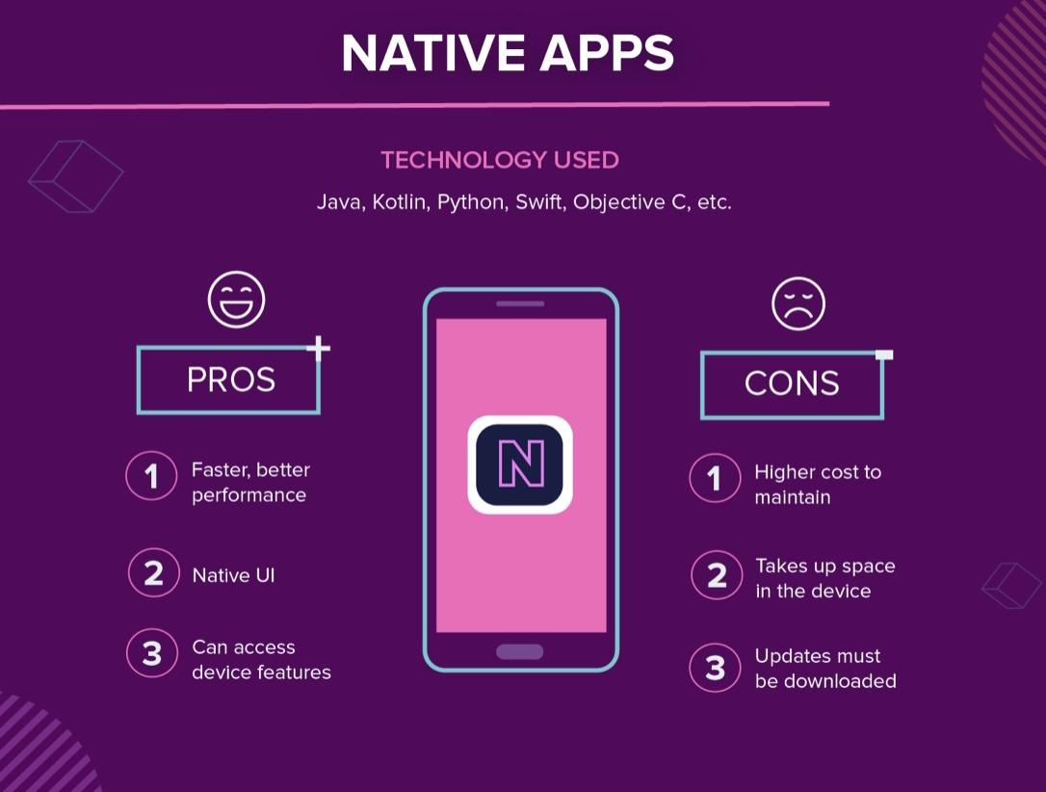

**2. Web Apps**

Web apps behave similarly to native apps but are accessed via a web browser on your mobile device. They’re not standalone apps in the sense of having to download and install code into your device. They’re actually responsive websites that adapt its user interface to the device the user is on.

**Technology used**

HTML, JavaScript, CSS

**Advantages**

* Because it’s web based, no need to customize to a platform or OS
* There’s nothing to download also. They won’t take up space on your device memory like a native app, making maintenance easier

**Disadvantages**

* Web apps are entirely dependent on the browser used on the device. There will be functionalities available within one browser and not available on another, possibly giving users varying experiences.

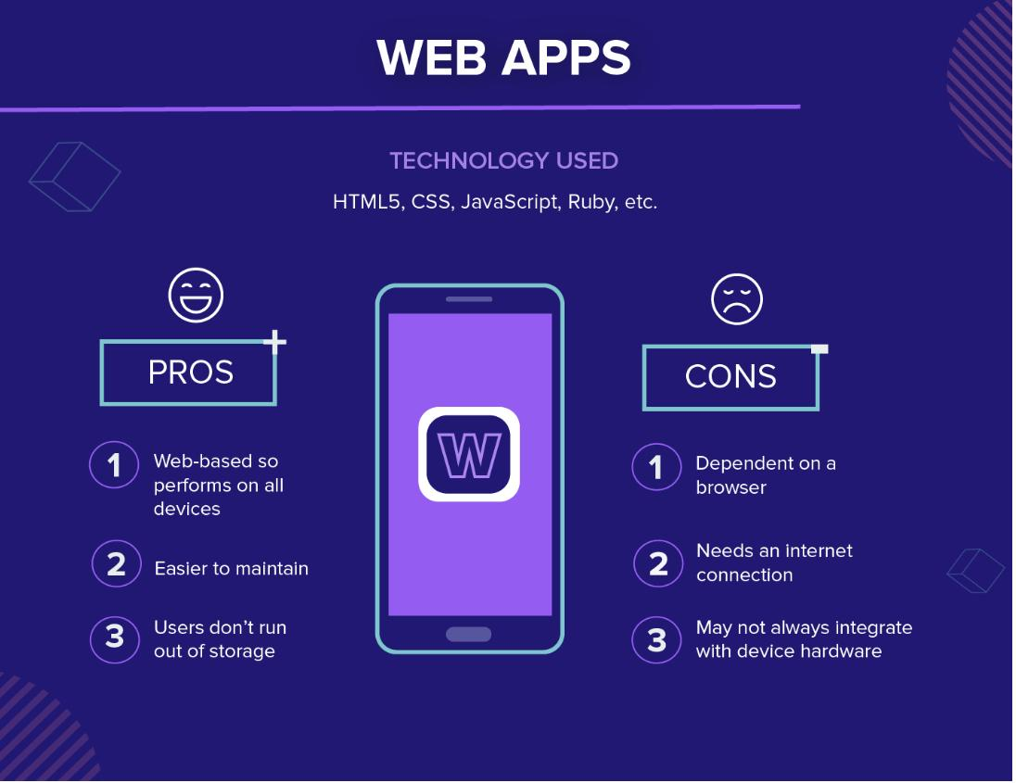

**3. Hybrid apps**

And then there are the hybrid apps. These are web apps that look and feel like native apps. They might have a home screen app icon, responsive design, fast performance, even be able to function offline, but they’re really web apps made to look native.

**Technology used**

Objective C, Swift, HTML5, and others.

**Advantages**

* Building a hybrid app is much quicker and more economical than a native app. They also load rapidly, are ideal for usage in countries with slower internet connections

**Disadvantages**

* Hybrid apps might lack in power and speed, which are hallmarks of native apps
* Decision factors to be considered when choosing the type of apps to build.

**Decision Factor: I Need an App ASAP!**

If you absolutely must have an app in the shortest amount of time possible, then you need to invest in building a web app. Not only will one codebase drastically speed up development time, but it will also mean that your users already have what they need to use it: a mobile browser

**Decision Factor: I Have Limited Resources**

Hi Web app or native app

**Decision Factor: My App Must Be Fast and Stable**

If performance is of the utmost importance, then there’s no way around it: you need to develop a native app. This type of app will give you the speed, stability, and customization features you deem crucial to your success.

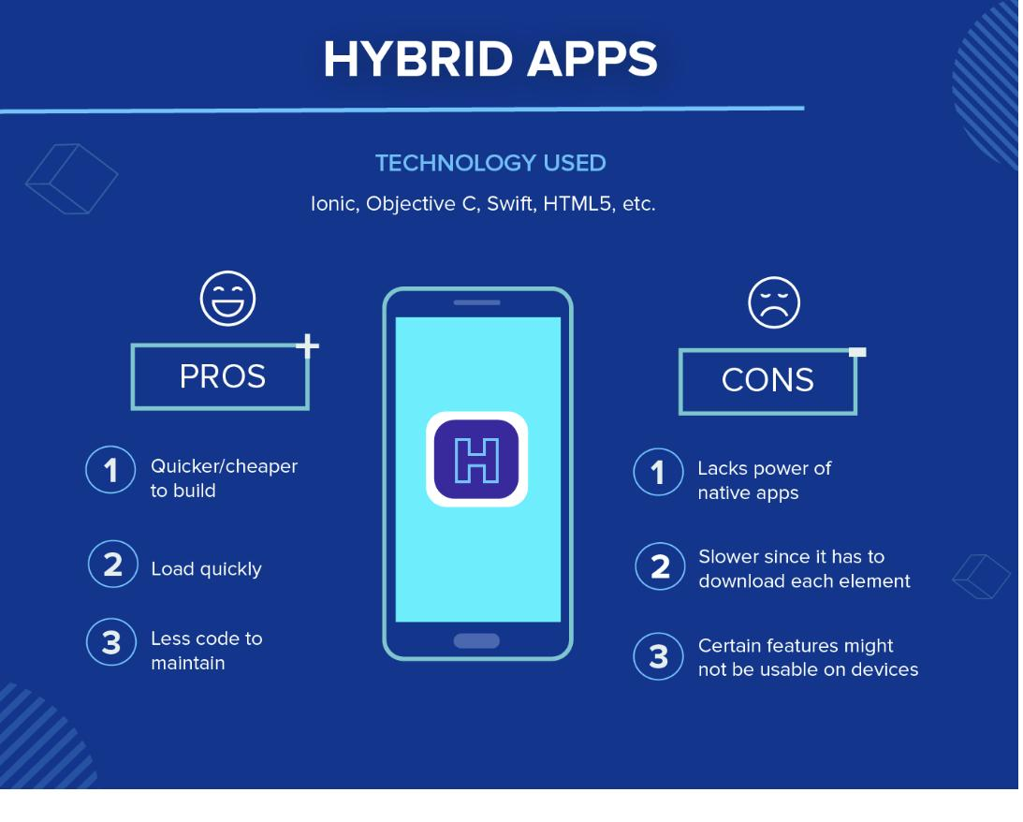

2. Review on Different Mobile Programming Languages

The choice of a particular method may greatly depend on your business goals and the corresponding capabilities of the operating system you choose as the platform, the type of application, and its requirements. Having an idea of app languages for creating mobile applications is useful not only for developers but also for their customers who want to better understand the project processes and know which language to pick best for their future projects. Let us review the main programming languages for iOS and Android mobile development here

**For iOS**

Objective-C & Swift

These are the key languages for writing iOS apps. They are object-oriented and make it possible to group similar tasks in the coding process, which significantly speeds up and simplifies the work of developers during front-end mobile app development. Besides, you may also apply:

C#

HTML5

Java

**For Android**

We have;

Python

Android developers who write mobile apps in the Python programming language are rare, but still, they do exist and have great Support from the huge programming community.

C / C ++

C languages are positioned as high-performance languages, and this is important, especially if we are talking about something heavy like a mobile 3D game.

without this language, you cannot create a full-fledged mobile application.

Java

Java mobile app development via java language – a strongly typed general-purpose object-oriented programming language is a popular thing to do. It often takes the highest places in the popularity ratings (2nd place in the IEEE Spectrum (2020) ratings, and on TIOBE (2021) alongside Python.

**For Web Apps**

We have

Scala

Scala combines object-oriented and functional programming in one concise, high-level language. Scala’s static types help avoid bugs in really complex applications.

JavaScript

This one is an interface language used for creating and developing websites, desktop applications, and games. JavaScript works in all browsers and can work with programs that are not hosted on the Internet

3. What is a mobile app development framework

A mobile app development framework is a software framework that allows mobile app developers to build their applications.

They are templates or fundamental structures that facilitate the work of developers as they build and optimize apps. Benefits of working within these rule-based templates or frameworks, it means developers are restricted in a way that helps them avoid making time-consuming programming errors so they can work faster and more efficiently.

3. REVIEW OF MOBILE APP DEVELOPMENT FRAMEWORKS

1. **FLUTTER MOBILE APP DEVELOPMENT FRAMEWORK**

Created by Google, it is a completely free and open-source mobile UI framework. It is one of the best mobile app development platform. The good thing about flutter is that you don’t have to write two separate codes, you can write one code and it will work for both Android and IOS.

**Benefits of using flutter**

*- It is easier to use

- Flutter allows you to create an Android and IOS application with one codebase.

- Saves time and decrease cost.

- Has built in functionalities to make your work easy and build the best mobile apps.

1. **XAMARIN MOBILE APP DEVELOPMENT FRAMEWORK**

XAMARIN is an open source framework created by Microsoft development of native and good-performance Android and iOS apps. It is one of the best in the market.

**Benefits**

- Xamarin provides one code for all platforms.

- Its performance is improved daily to completely match the standard of native application development.

1. **IONIC MOBILE APP DEVELOPMENT FRAMEWORK**

Ionic is an open-source framework that allows developers to build iOS and Android apps for flawless mobile performance. Developers can build a strong and well-featured native application with the help of this framework. Developers can use various UI elements like forms, navigation menus, filters, views, and actions sheets in the application design which are the most significant features of Ionic. It is a complete platform that allows developers to create PWAs (Progressive Web Apps ), cross-platform, and hybrid mobile applications.

**Benefits**

- You can create mobile apps by using any front-end framework you want

- It is great for beginners because it allows you to create mobile applications if you know HTML, CSS, and JavaScript.

1. **REACT NATIVE MOBILE APP DEVELOPMENT FRAMEWORK**

React Native is an open source mobile app development javascript framework created by Facebook.

**Benefits**

- Currently, React Native is preferred by a lot of companies as a solution because one can easily write all of the code in Javascript and share it on Android and iOS.

- It is one of the best frameworks

- Developers who use React Native, they don’t have to create separate codes for different platforms as JavaScript can be used for both Android and iOS platforms

- It is efficient and cost less

- React Native upgrades regularly to stay at the top of all mobile app development frameworks and this is the reason for its popularity.

1. **APACHE CORDOVA MOBILE APP DEVELOPMENT FRAMEWORK**

It is one of the best develop-friendly app development frameworks and uses CSS3, JavaScript, and HTML5 for the creation of mobile applications. Its plugins enable developers to access the hardware capabilities of devices like Cameras, GPS, and accelerometers for the delivery of a native-like app experience.

**Benefits**

- It is great for Hybrid applications as it can make Hybrid development easy and super fun.

- It is not just an HTML application that runs in a browser, it lets you write native plugins that work with all supported platforms

1. **NATIVE SCRIPTS**

It is an open-source framework to create native mobile applications empowered with Angular, Typescript, JavaScript, CSS, and Vue.js.

**Benefits**

- Native Script is a preferable framework to reduce the code and time of the app loads on the system.

- Many leading companies love using Native Scripts for its strong web empowerment Platform

- Full direct access to Android & iOS APIs

COMPARISON

|  |  |  |  |  |  |  |
| --- | --- | --- | --- | --- | --- | --- |
| Frameworks | language | performance | cost and time | user interface | complexity | community support |
| native script | typescript, JavaScript , css, vue.js | relatively slow performance | open source |  |  | medium |
| flutter | Dart | amazing | -open source  -Cheaper and faster | use proprietary widgets for stunning UI |  | not very popular |
| xamarin | c# | iOS/android close to native | -open source + paid plans  -cheaper and faster | use native UI controllers |  | strong |
| ionic | HTML, CSS, and JavaScript | moderate | -open source + paid plans  -cheaper and faster | CSS, HTML |  | strong |
| react native | JavaScript+,objective c, Java, swift | close to native | -open source  -Cheaper and faster | uses native UI controllers |  | very strong  as there is no web-view |
| Apache cordova | CSS3, JavaScript, and HTML5 | low | -cheaper and faster |  |  | not so popular |

4-) How to collect and analyze the requirements for a mobile app to be developed.

HOW DO U COLLECT AND ANALYZE THE REQUIREMENTS FOR A MOBILE APP TO BE DEVELOPED?

Before developing your mobile app, there are preparation steps you need to take which are;

1. **Perform market audience and competition analysis**

The way you perform analysis will determine the strength of your mobile app development strategy. If you cannot do detailed analysis, your entire app journey will become directionless and can end up in failure. So, you must conduct intense research to know and serve your target audience. Some of the research to perform are learning some mobile apps and their failures such as lack of originality, poor user experience, not selecting the right mobile app development platform and etc.

1. **Choose the type of mobile app you want**

After proper analysis, choose between native, hybrid or web app as per your business requirements. You must understand what type of mobile app and platform is suitable for you to help your app survive and thrive.

1. **Understand your monetization options**

It is the key to making money in your app. consider analyzing the different forms of monetization like advertising, in-app purchases, subscriptions, sponsorships, and data monetization. Make sure to keep your user experience intact while your app generates growing revenue for you.

1. **Create your marketing plan**

Set your foot right in the app store for maximum installations, and retain users over the long term for your long-term benefit.

1. **Know your timeline and resources**

Write down your timeline, budget, due dates for different stages and the resources you’re going to work with to avoid any emergencies and delays further down the line.

1. **Take security measures**

Consider including a privacy policy if you run a mobile app that collects personal information from the app users. You could develop the most mind-blowing app in the store – but if you neglect planning and implementation of crucial security measures, you’re going to invite potential security risks.

1. **Adopt agile techniques for frequent releases**

You need to adopt tried and tested agile methodology for your mobile app development. Also, you’ll find that incorporating best practices like unit testing, continuous integration, and frequent releases get much better results.

1. **Test your app after deployment**

While it’s important to perform thorough tests before launching a mobile app, it’s also necessary for your app after deployment. it will help you solve issues that you didn’t notice before like performance problems, poor user interface, or crashing to ensure that the app released to the market is of superb quality

1. **Enable offline capabilities**

The greatest advantage that the developers like to play up is the fact that enabling offline capabilities in your mobile app will provide a positive user experience.

How to estimate mobile App development cost

The price of developing an app depends upon what type of app you’re building. Generally, the average rate of building an app ranges from $40,000 to $150,000, depending upon the complexity of the app.

If you are considering developing an app, it is important to understand all the factors that can affect the cost. Some factors influencing the app development cost are:

* Size of app
* Features and functionality
* The complexity of visual design*
* Android or iOS
* Hiring a freelance developer or a software development agency**
* Backend infrastructure*

**Size of App**

The cost of developing an app can be affected by the size of the app: small, medium or large Apps. Small Apps have standard user interface elements, are designed for a single platform, have fewer features, no backend coding is required. For medium Apps the UI and payment methods are standard. Larger Apps require many more features, support multi-language, extensive backend development to store and manage massive databases and much more e.g an Uber.

**Features and functionalities**

The features and functionalities of an App contribute greatly to the cost of the App development. Building an App with fewer features takes a lesser amount of time hence the cost of development will be less. On the other hand complex features in an App requires more time leading to a higher App development cost. These functionalities includes whether the App should be multi-languaged, should contain user-login(via email, via text or via social media account) or not(no login required), the type of customer support you require (such as realtime chats where agents will answer questions of the users in realtime or contact form where users will fill a form to get in contact with the support services) or no customer support, whether users can communicate in the App, the presence of a chat(1-1 messaging, Group chat and file sharing between users), the type of gratification features (such as “Like system” or “Rating system”) or none, the type of security(standard with security featured such as authorization, confirmation, email or advanced security).

**Android or iOS**

Android is a mobile operating system used in Blackberry, Samsung, HTC. IOS is a mobile operating system used in iphones. iOS running Apps are less expensive then Android running Apps because the scope for device fragmentation is much wider for Android than ios Apps. IOS comes with about 20 different types of devices while hundreds of different mobile devices are supported by Android so building an Android App will require you to adapt it to different fragmentations making Android App development cost a bit higher. Also Android emulators perform much slower than ios simulators so much amount of time is spent on Android App testing for all the different versions of an Android leading to more development hours hence making the development cost a bit higher.